Chapter 16, Problem 50.

For the circuit in Fig. 16.73, find v(t) for t > 0. Assume that v(0⁺) = 4 V and
i(0⁺) = 2 A.

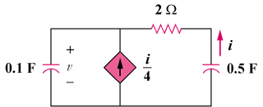

Figure 16.73
For Prob. 16.50.

